**EXPERIMENT NO:01**

**AIM:Build a DataWarehouse for a given problem statement.**

**PROBLEM STATEMENT:**

A Hotel Reservation System manages the database of a hotel, client, city, hotelier details. It allows the user to select location of the hotel since branches are located in multiple cities across the globe. It lets user to select the number of rooms, room type, overnight staying and prices. User will select the dates of reservation for the number of nights of stay.

**FUNCTIONALITIES:**

1. Every online booking is associated with an account.
2. Every account is limited to a single user.
3. Enable users to search and find the most relevant booking options.
4. Accept date to check available rooms for that particular time.
5. Booking confirmation should be sent to the specified contact details.
6. Calculate and display accommodation charges and other utilities.
7. Cancel bookings.
8. Display and change records of guest.
9. Change rooms.

**ER MODEL:**

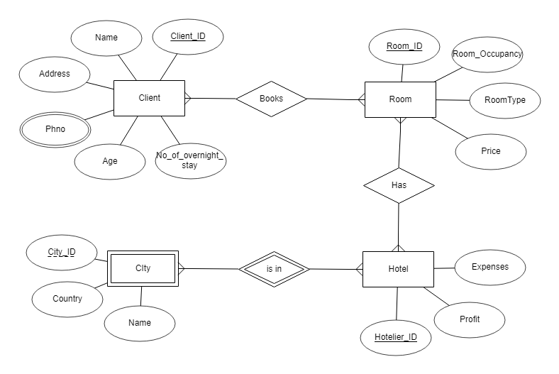

**IPD:**

Dimensions

|  |  |  |  |
| --- | --- | --- | --- |
| **Client** | **Dates** | **City** | **Rooms** |
| Client_ID | Date_ID | City_ID | Room_ID |
| Name | Year | Country | Room type |
| Address | Month | City | Room occupancy |
| Age | Day | Hotelier_ID | Price |
| Phone_number | Week | Hotelier_Name |  |
| Gender |  |  |  |
| Measured Facts: Number_of_overnight_stay, Profit, Expenses | | | |

**THEORY:**

**IPD DEFINATION:**

An information package diagram defines the relationships between subject matter and key performance measures. The information package diagram has a highly targeted purpose, providing a focused scope for user requirements.

Information Packages –novel idea for determining and recording information requirements for a data warehouse.

Determining requirements for a data warehouse is based on business dimensions

The relevant dimension and measurements in that dimension are captured and kept in a data warehouse

This creates an information package for a specific subject

**DIMENSION MODEL/STAR SCHEMA:**

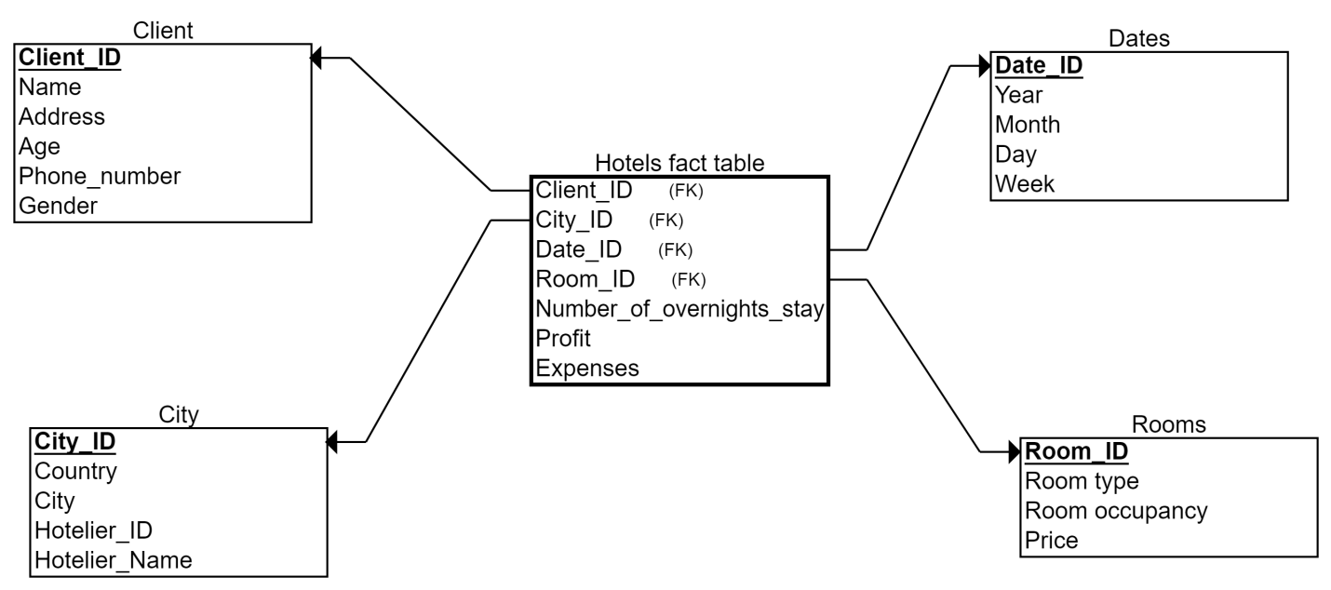

**Analytical Queries for system:**

1.Total number of rooms booked by gender country wise with subtotal and grandtotal (Use rollup()).

2.How many reservations have been made in all countries till date.

3.Sum of expenses in all countries room and countrywise using cube().

4.Which city gives the maximum profit with respective rooms for all(Use Rank()).

5.Which city gives the maximum profit with respective rooms (Use DENSE Rank()).

6.What is the overall profit from 13-May-12 to 04-Nov-15 per city ?(SLICE)

7. What is the overall profit and expense from 15-Oct-15 to 01-Jul-19 ?(DICE)

8.What is the total number of overnight stays overall in all hotels.

9.Total number of rooms allocated of all locations in India.

10.What are the total Expenses of a Spain Branches ?

**Conclusion:**

In this experiment, we learnt about what is a datawarehouse and its components. We made a problem statement and gave system functionalities. We built a ER model, Dimensional Model ,IPD for the problem. Then we wrote Analytical queries for the system. We also created Data marts and Data warehouse for the system.